**Tutorial of BST and AVL Tree**

**1. BST**

1. Show the result of inserting 3, 1, 4, 2, 5, 6, 9, 7, 12, 8, 10, 13, 11 into an initially empty binary search tree.

Solution:

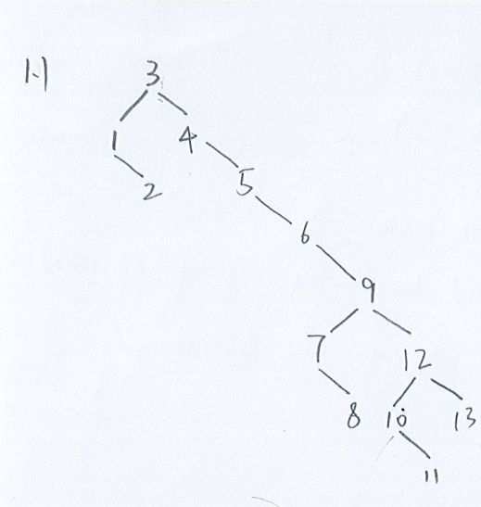

1. Please write down the **Inorder** traversal of the BST

Solution:

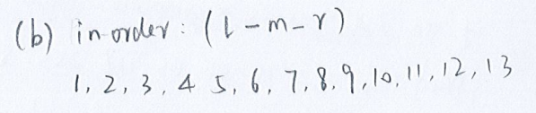

1. Please write down the **Preorder** traversal of the BST

Solution:

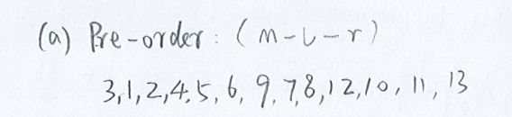

1. Please write down the **Postorder** traversal of the BST

Solution:

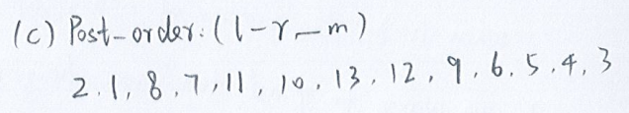

1. Show the result of deleting of node “2”
2. Show the result of deleting of node “5”

Solution:

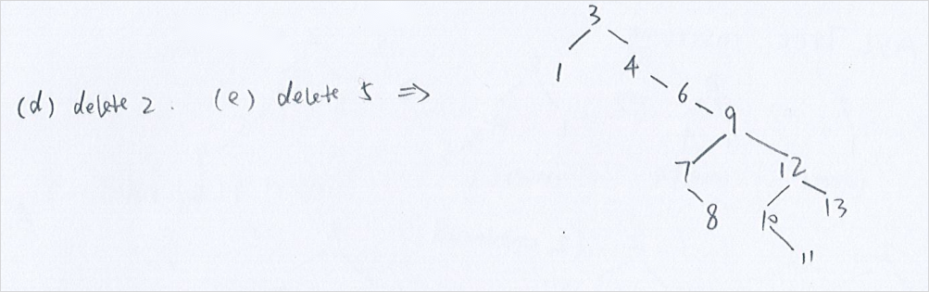

1. Show the result of deleting of node “9”

Solution:

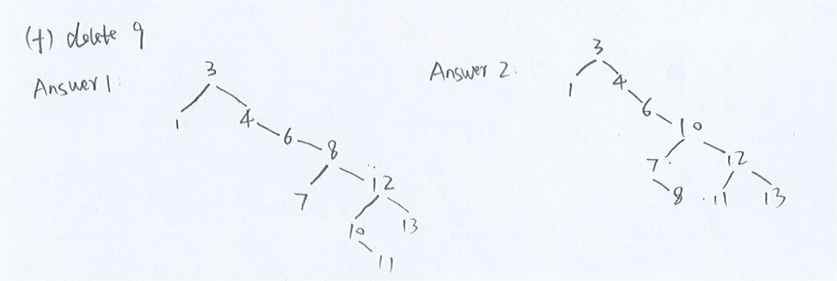

1. A full node is a node with two children. Prove that the number of full nodes plus one is equal to the number of leaves in a nonempty binary search tree.

Solution:

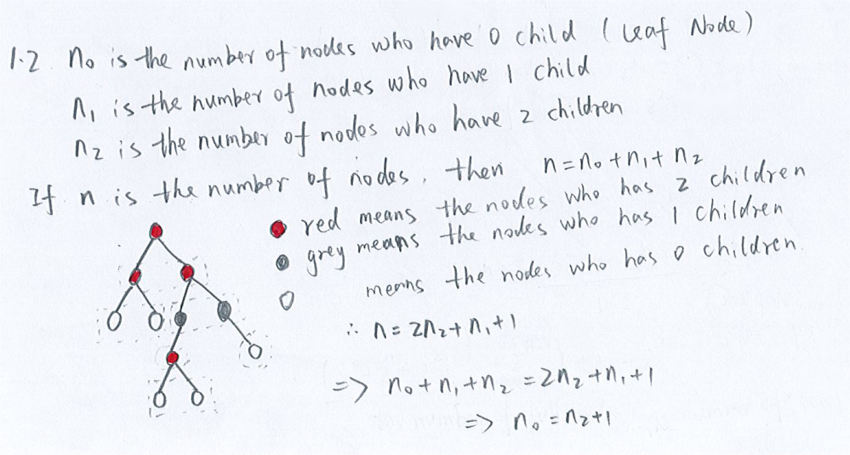

1. What is the **maximum** and **minimum height** of a binary search tree with n node?

Solution:

maximum :

minimum:

1. What is the **time complexity** of Search, findMax, findMin, Insertion and Deletion of a binary search tree?

Solution:

O(tree height)

Best case: O()

Worst case:

**2. AVL Tree**

1. What is the **maximum** AVL Tree **height** of 90 nodes?

Solution:

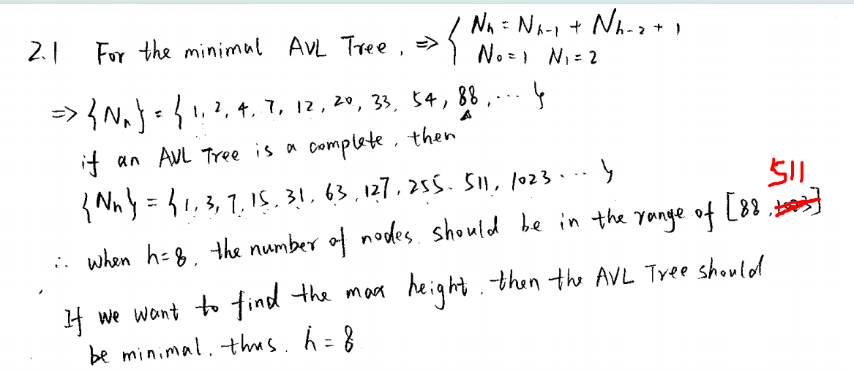

1. Show the result of inserting **2, 1, 4, 5, 9, 3, 6, 7** into an initially empty AVL Tree.

Solution:

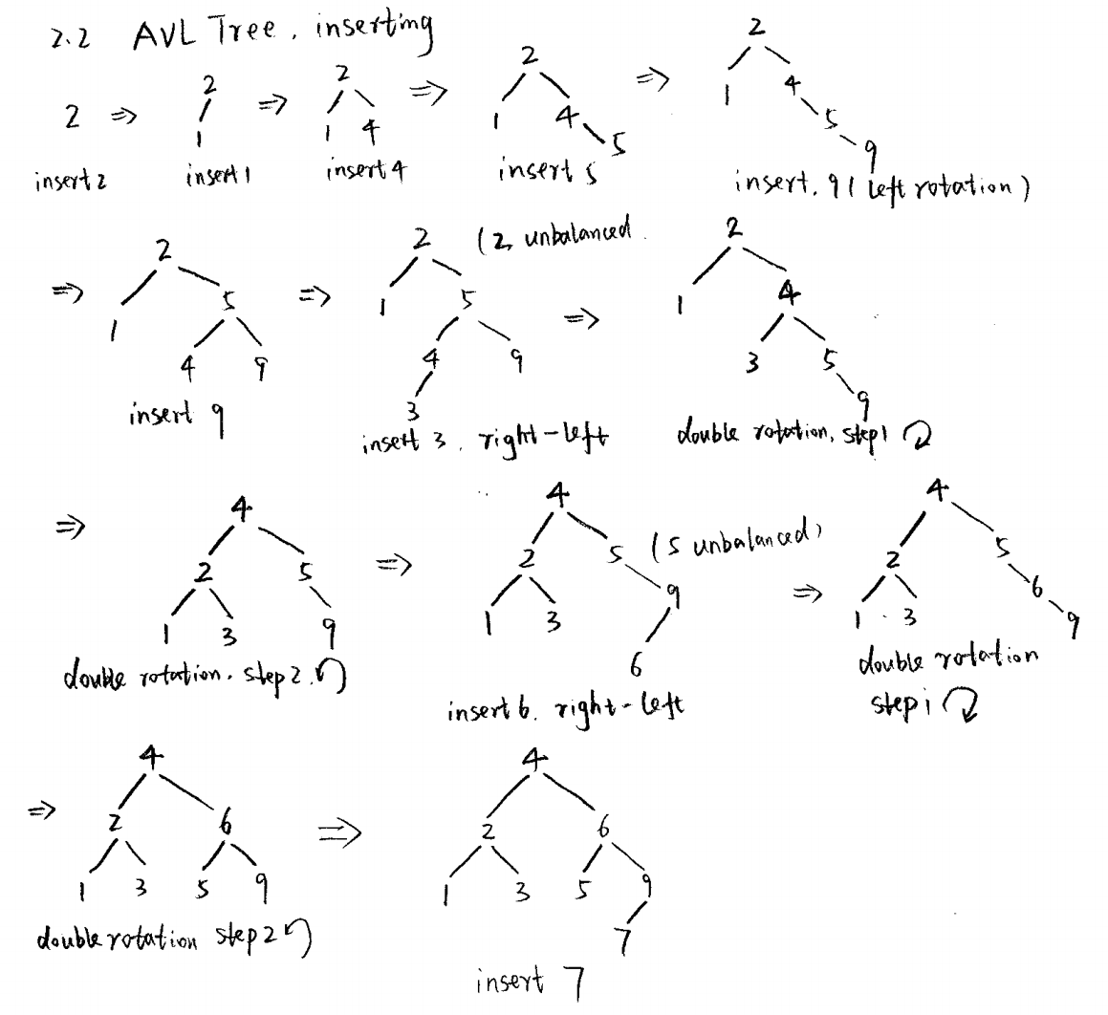

1. Show the result of deleting node **“1”** and **“3”** from the AVL Tree in **2.2**

Delete “1”:

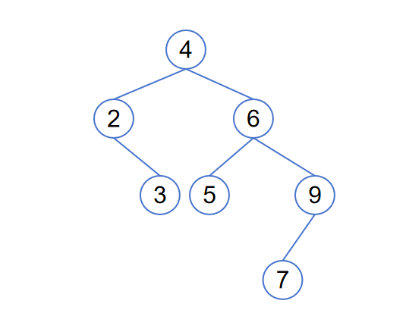

Delete “3”:

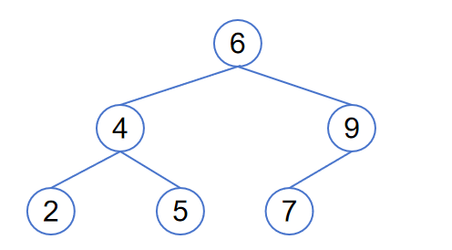

1. Show the result of deleting **root** from the AVL Tree in **2.2**

Method 1: Replace root with maximum node in the left subtree

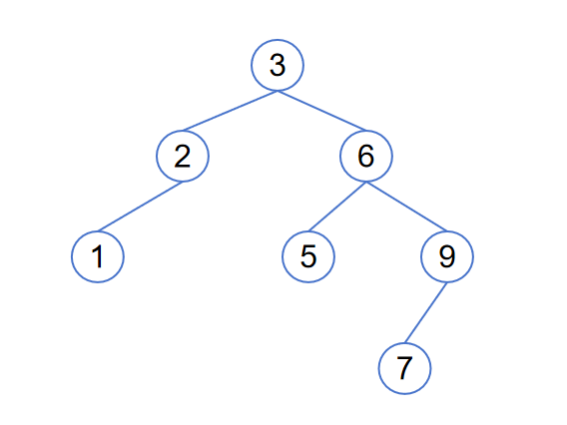

Method 2: Replace root with minimum node in the right subtree

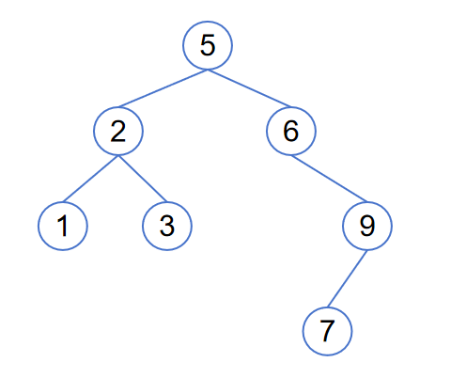

In this case node 6 is unbalanced, double rotation:

